Preparation: Extract Firmware to USB memory Disk

Upgrade Method from User Menu
- Plug into the USB Memory Disk.
- Choose setting from Menu
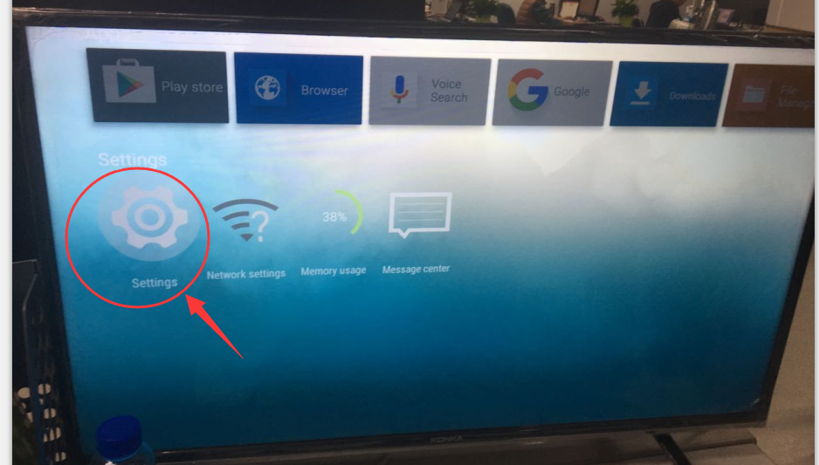
- Choose Update from device
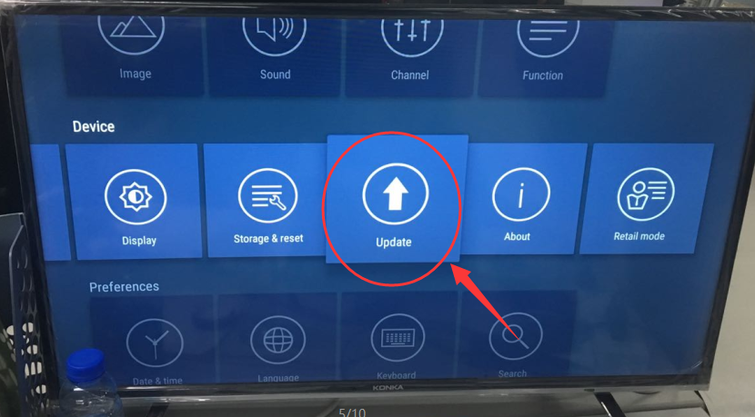
- Choose local Update
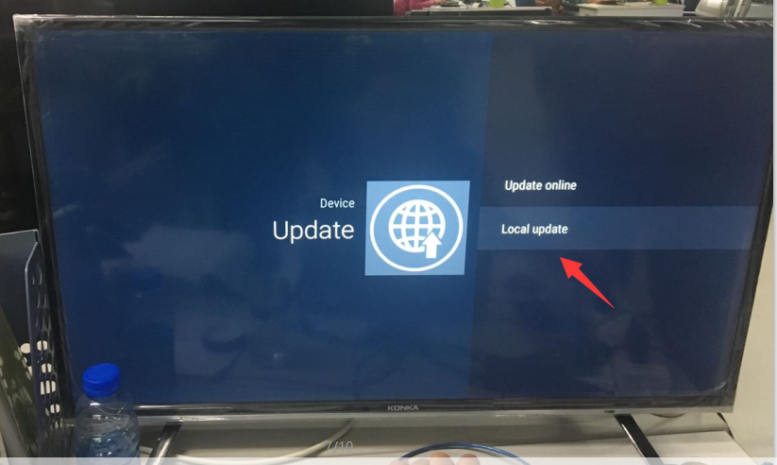
- Choose Ok
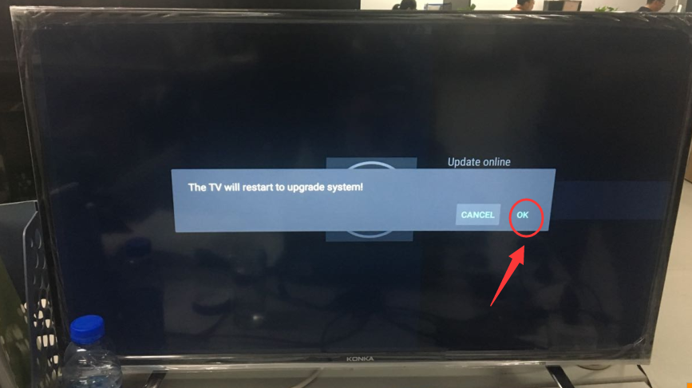

- Waiting for 100% upgrade finished. No need Power off/on again.
